Calvin Wong
CISC 3140
Prof.Katherine Chuang
Lab Activity #4

Part 1 :

To login into the BC Linux server, I first emailed Raymond Patitucci (RPatitucci@brooklyn.cuny.edu) to attain the login credentials. After acquiring the login credentials, I proceeded to open the terminal since I am on the Macintosh operating system. Upon opening the terminal, I type in ssh followed by a space and the username provided Raymond Patitucci, followed by the @ symbol and one of the IP addresses provided. Once that is entered, you will be prompted to enter the password for your BC Linux server. After entering the correct password, you will be successfully logged in, indicated by your username followed by @sol.
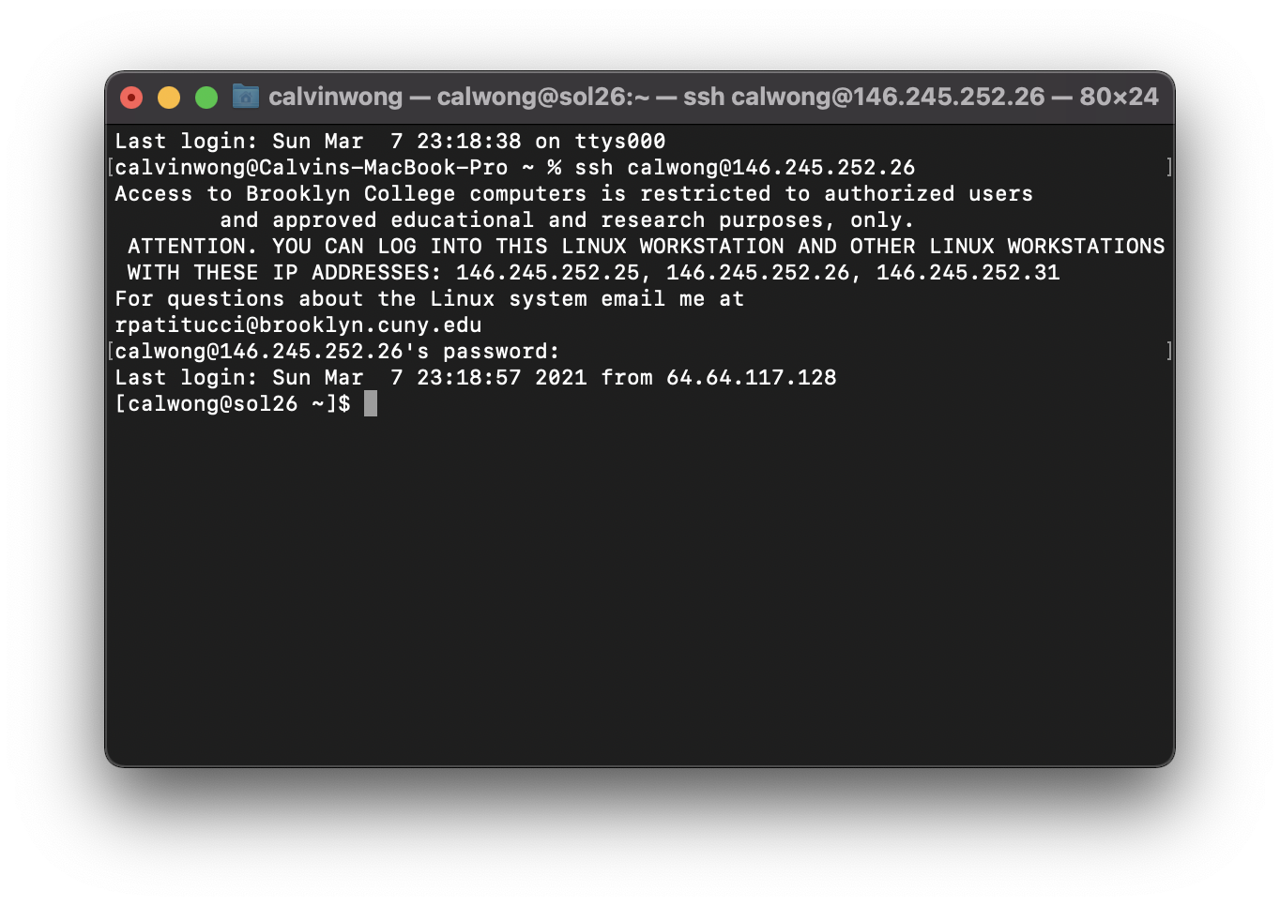
Screenshot of login process
Part 2 :

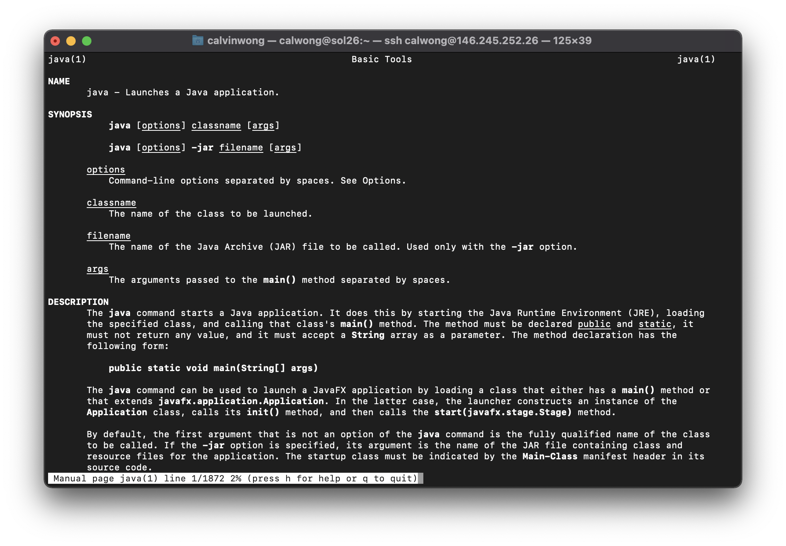
Once I successfully logged into the server, I used the provided sample commands such as whoami, man, git —version, and which. The screenshot below shows the command “man” which displays all the information surrounding that specified application, in this case, Java. Navigating the BC Linux server through the various commands was much quicker and more efficient. In my opinion, I prefer using the command line terminal over a graphical user interface as it is much more straightforward, and it allows you to securely access a specific machine through any other machine by using the ssh command.
Display of man Java command

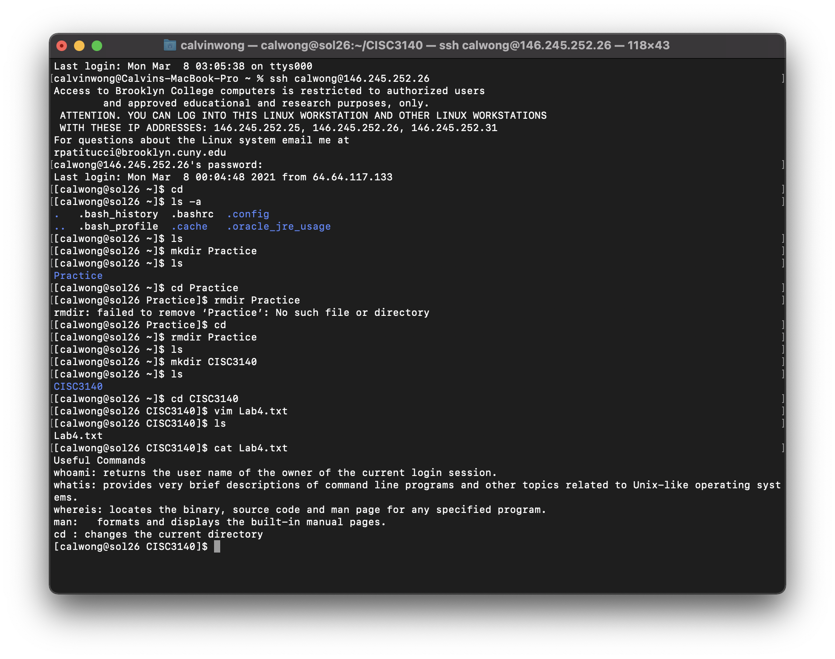
Part 3:
Using the terminal to open the text-file created using VIM

